Domain Model
# Source: AI Source: Provided by: [Data Path: Persons Table -> ID Column: 1, Name_En Column: Motasem Essam] -> From: [ChatGPT] on [1/23/2026]
The Domain Model represents the core business logic and rules of the application.
It combines Entities, Value Objects, and behaviors to model how the business actually works.
👉 The Domain Model is the heart of the system — it reflects real-world concepts and rules

🔑 Key Idea
# Source: AI Source: Provided by: [Data Path: Persons Table -> ID Column: 1, Name_En Column: Motasem Essam] -> From: [ChatGPT] on [1/23/2026]
- Represents the business domain
- Contains logic, rules, and relationships
- Not just data — includes behavior

🧱 What Does It Include?
# Source: AI Source: Provided by: [Data Path: Persons Table -> ID Column: 1, Name_En Column: Motasem Essam] -> From: [ChatGPT] on [1/23/2026]
Domain Model =
Entities + Value Objects + Business Logic + Relationships

🧩 Example – E-Commerce Domain
# Source: AI Source: Provided by: [Data Path: Persons Table -> ID Column: 1, Name_En Column: Motasem Essam] -> From: [ChatGPT] on [1/23/2026]
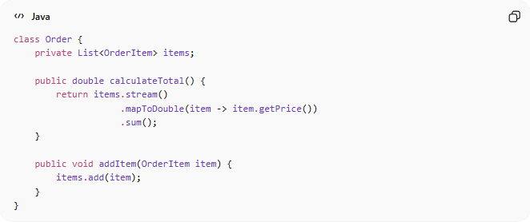
class Order {
private List<OrderItem> items;

public double calculateTotal() {
return items.stream()
.mapToDouble(item -> item.getPrice())
.sum();
}

public void addItem(OrderItem item) {
items.add(item);
}
}
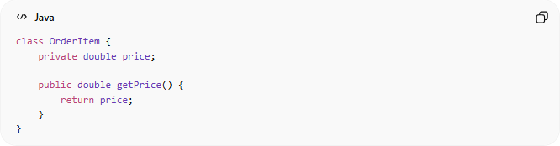
class OrderItem {
private double price;

public double getPrice() {
return price;
}
}
👉 Here:
- Order = Entity
- OrderItem = part of the domain
- calculateTotal() = business logic

❌ Bad Example (Anemic Domain Model)
# Source: AI Source: Provided by: [Data Path: Persons Table -> ID Column: 1, Name_En Column: Motasem Essam] -> From: [ChatGPT] on [1/23/2026]
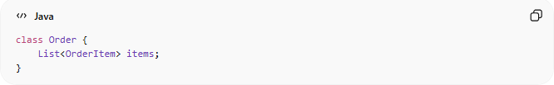
class Order {
List<OrderItem> items;
}
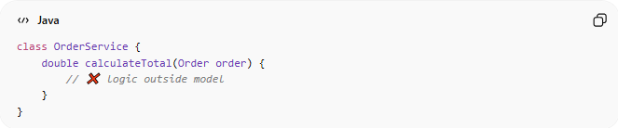
class OrderService {
double calculateTotal(Order order) {
// ❌ logic outside model
}
}
👉 Problems:
- Model has no behavior
- Logic scattered
- Hard to maintain

✅ Good Example (Rich Domain Model)
# Source: AI Source: Provided by: [Data Path: Persons Table -> ID Column: 1, Name_En Column: Motasem Essam] -> From: [ChatGPT] on [1/23/2026]
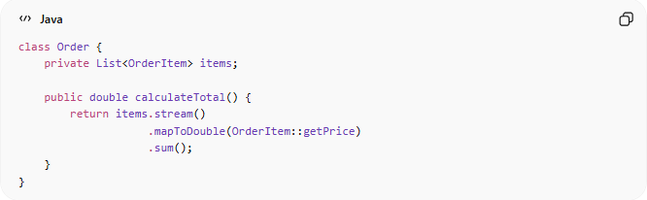
class Order {
private List<OrderItem> items;

public double calculateTotal() {
return items.stream()
.mapToDouble(OrderItem::getPrice)
.sum();
}
}
👉 Benefits:
- Logic is inside the model
- Easier to understand
- Matches real-world behavior

🔄 Domain Model vs Other Models
# Source: AI Source: Provided by: [Data Path: Persons Table -> ID Column: 1, Name_En Column: Motasem Essam] -> From: [ChatGPT] on [1/23/2026]
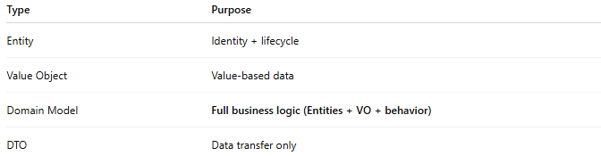
Type | Purpose
Entity | Identity + lifecycle
Value Object | Value-based data
Domain Model | Full business logic (Entities + VO + behavior)
DTO | Data transfer only

🔄 Where It’s Used
# Source: AI Source: Provided by: [Data Path: Persons Table -> ID Column: 1, Name_En Column: Motasem Essam] -> From: [ChatGPT] on [1/23/2026]
- Domain-Driven Design (DDD) → Core concept
- Clean Architecture → Domain layer
- Complex business systems

⚠️ Common Mistakes
# Source: AI Source: Provided by: [Data Path: Persons Table -> ID Column: 1, Name_En Column: Motasem Essam] -> From: [ChatGPT] on [1/23/2026]
- Creating anemic models (no logic) ❌
- Putting logic in Services instead of Model ❌
- Mixing domain logic with UI or database ❌

💡 Key Idea
# Source: AI Source: Provided by: [Data Path: Persons Table -> ID Column: 1, Name_En Column: Motasem Essam] -> From: [ChatGPT] on [1/23/2026]
Domain Model = business logic + real-world representation

🧾 Summary
# Source: AI Source: Provided by: [Data Path: Persons Table -> ID Column: 1, Name_En Column: Motasem Essam] -> From: [ChatGPT] on [1/23/2026]
Domain Model:
- Represents business rules and logic
- Combines Entities + Value Objects
- Should be rich (not just data)
- Is the core of well-designed systems

